Lab 2 Report

ECSE 426 – Microprocessor Systems

Group 7

Gregoire Martin – 260364773

Patrick White – 260353491

October 21st 2013

# Table of Contents

1. Abstract 3

2. Problem Statement 3

3. Theory and Hypothesis 4

4. Implementation 6

5. Testing and Observations 10

6. Conclusion 12

Figure 1: Duty Cycle (PWM) (Instruments) 5

Figure 2: Bouncy Signal (Express) 6

Figure 3: Flowchart of overall system 6

Figure 4: Temperature Tracking Flowchart 8

Figure 5: LED updating algorithm 9

Figure 6: Matlab Filter Results 11

# 1. Abstract

The primary goals of this experiment are to provide a simple graphical output of the processor core’s temperature using the STM32Fx board’s LEDs, to implement a simple pulse width modulation (PWM) algorithm and demonstrate its correctness using the board’s LEDs, and to provide to the user a method of selecting between the modes of operation using a button. This experiment involved the use of a sensor, timers, basic input and output, as well as some basic signal processing for the sensor and for a button.

The voltage value of the temperature was found using an analog to digital converter (ADC) on the temperature sensor. This value was input into an equation from the STMFx datasheet (STMicroelectronics, 2013) to obtain the Celsius value of the temperature. Since the readings from the sensor contain some noise, a moving average filter was implemented. The size of the filter window was determined to be 10 by analyzing the filter return for steady temperatures.

The PWM algorithm is achieved using two counters and increasing the timer frequency to 100MHz. The LEDs are held on progressively longer each cycle (certain count of 100MHz pulses) until finally they are on the entire cycle (other count reaches final value). This gives the effect of slowly increasing the LEDs intensity.

The entire system functions on the board as expected. The button press has been debounced to successfully register almost all switches between operating modes.

# 2. Problem Statement

The end goal of the experiment is to have a simple LED display indicate whether the board is heating up, cooling down, or maintaining its temperature, as well as demonstrating PWM using the same LEDs and allowing the user to select the mode of operation. The problem can effectively be broken down into five parts:

* Acquiring data from the temperature sensor
  + The data from the temperature sensor must be acquired as a voltage value and converted into a temperature using a formula provided in the datasheet.
  + The data must be sampled at a high enough rate to be useful.
  + The raw voltage readings are provided in analog format, thus the data must be converted to digital format in order for the processor to be able to use it.
* Filtering noise out of the signal
  + The signal is expected to be very noisy. A filter must be used to improve the quality of the signal and get rid of the unwanted noise.
* Updating the LEDs according to the temperature
  + The four main LEDs on the board must light up in a clockwise fashion with only one LED on at a time when the core temperature is increasing, and they must turn on in a counter clockwise fashion with only one LED on at a time. The LEDs must change whenever the temperature changes by 2 degrees Celsius.
* Developing the PWM algorithm
  + The LEDs intensity must be ramped up gradually starting from off (0) to their maximum brightness. This algorithm must be repeated.
  + This can be achieved by holding the LEDs on for an increasing larger percentage of a certain duty cycle. The LEDs will be on 100% of the final cycle.
* Providing the user a way of selecting between the two modes of operation
  + The user should be able to select between PWM and temperature tracking by simply pressing a button on the board.
  + The signal from the button will be noisy because of contact bounce, and a way must be devised to obtain a clean reading from the button

These five aspects will allow the board to provide a simple display to the user that describes the temperature trend of the processor’s core, as well as demonstrating PWM on the board’s LEDs and allowing the user to easily select the desired mode of operation.

# 3. Theory and Hypothesis

The values obtained from the temperature sensor will originally be voltages in an analog format. Because the readings are in an analog format, Analog-Digital conversion must be used to convert the data into a format that the processor will be able to use.

From the STM32Fx datasheet (STMicroelectronics, 2013), the formula to convert the voltage reading from the temperature sensor into a temperature in degrees Celsius is

$$Temperature= \frac{V_{measured}-V_{25}}{0.0025}+25$$

Where V25 is the voltage measured at 25 degrees Celsius, or 0.76 V.

It is expected that the voltage readings from the sensor will have unwanted fluctuations which will make appear that the temperature is varying far more than it actually is. This noise can be caused by many sources; electromagnetic interference, thermal noise, quantization noise from the ADC among other things. The signal must be processed in such a way to filter as much of this noise as possible. A very simple filter we can use is the moving average filter. The moving average filter keeps a buffer of the D most recent samples, and takes the average of those values and outputs that average. When a new measurement is taken, the oldest measurement in the buffer is discarded, the new measurement added to the buffer, and the average recomputed.

In general, a smaller window would be better suited to the task at hand in order to preserve the resources of the system, while reducing the noise in the signal to an acceptable level. For example, a filter depth of 5 may be desirable.

The LEDs on the board are driven by digital signals. Because of this, they are either in an on or off state. However, the LEDs have the ability to toggle state really quickly. To display different LED intensities, or even ramp up from a low intensity to full intensity, a duty cycle must be used. A duty cycle involves maintaining a signal high for a percentage of a cycle. As demonstrated in Figure 1, a larger duty cycle indicates the signal being high for a larger portion of the cycle. By increasing the duty cycle percentage linearly and driving the LEDs to high when the signal is high, it is expected that an increase in the LEDs intensity will be observed.

This will be implemented using two counters. One counter will be a time base. The second counter will increment every time the time base is hit. The LEDs will be held on for a percentage of the time base equal to the second counter count divided by the time base. At the end of the algorithm, the second counter will have a count equal to the time base count and the LED will be held on for the entire cycle.

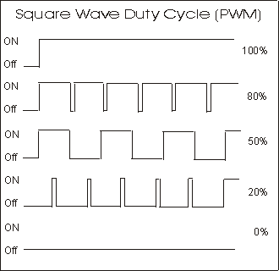

Figure : Duty Cycle (PWM) (Instruments)

In order to obtain a clean reading from the push button, some basic signal processing will have to be applied to the reading because of contact bounce. Contact bounce occurs because many buttons are made of springy metals. When the spring comes into contact with the electrical contacts, it will result in a “bouncy” signal where the bit value may rapidly pulse between 0 and 1 for a short period of time, preventing the programmer from reliably knowing if the button was pressed. This can be seen in Figure 2. It will be necessary to “debounce” the button using some very basic software functions. To debounce means to correctly detect the button press. A simple way of doing this is to check for both a press and a release. If the bit indicating a press is set, wait a short period of time, and then check if it’s been unset. This gives the signal time to be fully asserted, and fully de-asserted before the bit readings are taken.

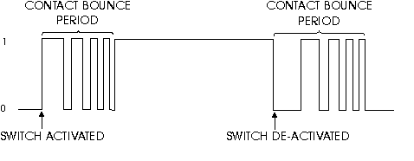

Figure : Bouncy Signal (Express)

# 4. Implementation

The system designed to meet all the requirements of the problem statement can be seen in Figure 2. After initializing the temperature sensor, the ADC, the LEDs, the filter window and the timer, the system enters into a continual loop. A simple two state machine is implemented to switch between displaying the temperature tracking algorithm on the LEDs and displaying the PWM algorithm. The machine switches state on a button press. The PWM algorithm requires a much faster timer than temperature tracking and thus, the timer count is reconfigured every time there is a state change.

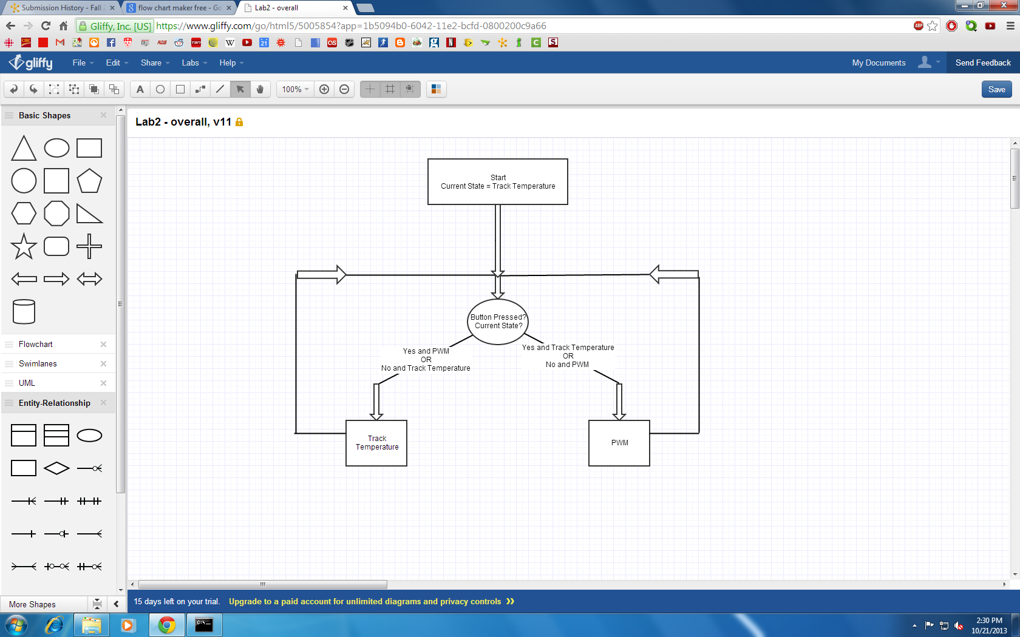

Figure : Flowchart of overall system

The first mode of operation involves temperature tracking. To obtain the readings from the temperature sensor, the ADC had to be initialized. For the temperature sensor, ADC 1 is used. The ADC is configured to return 12 bits. The true reading is intended to be in the range of 0 to 1. This indicates a resolution of 12 bits (12 bits used to represent number between 0 and 1). Increased resolution allows for greater precision, however, it also consumes more system resources. A healthy balance is desired. The ADC is set to continuous conversion mode. This means that at any given point in time, the voltage value read will be stable. Then, the ADC conversion is started.

In accordance with the specification, the sensor was to be sampled at 20 Hz. To get this sampling frequency, the board’s timer was used. The board’s system core clock has a frequency of 1. Using ARMs SysTick timer, different frequency pulses can be generated as divisions of the system core clock. The SysTick timer was set to issue an interrupt 20 times per second or one every 50 milliseconds.

When the interrupt is received, it signals that a new reading from the temperature sensor should be taken. The first thing to happen is that the timer is reset to begin counting until the next interrupt. At this point, the value returned by the temperature sensor is read in from the ADC. The value returned by the ADC is a voltage value, and thus it must be converted appropriately to get the actual temperature detected by the sensor. The voltage is divided by 4095 (or 212 – 1) in accordance with the bit resolution of 12 to obtain the fraction of the reference voltage detected by the sensor. This fraction is then multiplied by 3 V, to obtain the actual voltage detected by the sensor. The actual voltage is then applied to the formula to obtain the temperature reading. The temperature value needs to be cleaned up using some basic signal processing in order to increase the reliability of all the temperature readings.

To filter the noise from the readings of the temperature sensor, a moving average filter was employed. The filter was implemented as a C struct. A ring buffer technique was employed to avoid having to shift all the buffer values at the addition of each new temperature reading. The struct hold an array of length D to represent the buffer, the sum of all the values in the buffer, the average of all the values in the buffer, and the index to keep track of the next position to insert a value. Every time a new value was read from the sensor, it would be written to the buffer, the sum and average would be recomputed, and the index incremented or reset in order to wrap around when it reached the end of the buffer.

To optimize the moving average filter, a Matlab model was used to compare different buffer lengths and the resulting quality of data. The moving average filter was applied to several data sets from the temperature sensor, and the buffer length was varied. After running several data sets through the Matlab model, it was determined that a buffer of length 10 would be used. For the specifics of the testing and optimization, see Section 5: Testing and Observations.

The filtered temperature readings were then applied to the problem of implementing the rotating LEDs to show the temperature trend. The variables tracked for this problem were the current LED illuminated, the new filtered temperature reading, and the base temperature. The LEDs are numbered 0 to 3, with clockwise representing increasing values. In other words, LED 1 is one position clockwise from LED 0, and accounting for the wraparound, LED 0 is one position clockwise from LED 3. The inverse is true for the counterclockwise sequence. The base temperature is the value that last caused a change of LED. After the new temperature value is filtered, it is passed to a function that updates the LEDs.

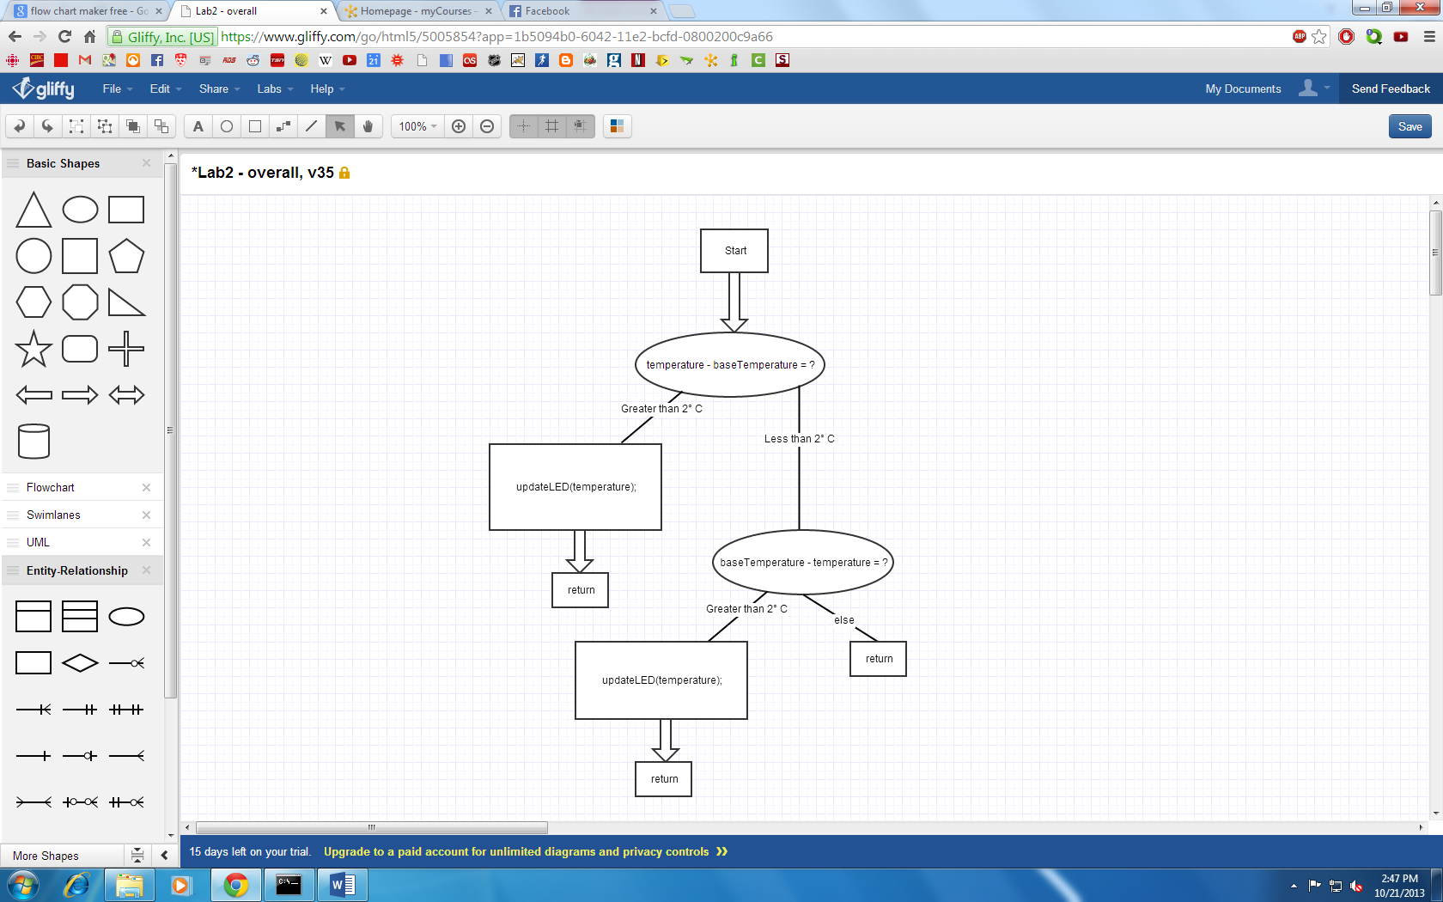

Figure : Temperature Tracking Flowchart

The function initially checks if the new temperature is at least 2 °C greater than the base temperature (the temperature that last caused the LEDs to change). If the new temperature satisfies this condition, it means that the LEDs must change with the current LED being turned off and the LED immediately clockwise of the current LED must be turned on. At this point, the function checks which LED is currently illuminated, writes a bit value of ‘0’ to GPIO pin of the current LED, and then writes a bit value of ‘1’ to the GPIO pin of the next LED clockwise from the current one. Finally, the function updates the current LED variable to the LED that was just turned on, and updates the base temperature to the temperature value that caused the change in LED.

In the case where the new temperature is not at least 2 °C greater than the base temperature, the function next checks if the new temperature is at least 2 °C less than the base temperature. If this condition is satisfied, this means that the LEDs must change with the current LED being turned off and the LED immediately counterclockwise of the current LED must be turned on. The function checks which LED is currently illuminated, writes a bit value of ‘0’ to the GPIO pin of the current LED, and then writes a bit value of ‘1’ to the GPIO pin of the next LED counterclockwise from the current one. Finally, the function updates the current LED variable to the LED was just turned on, and updates the base temperature to the temperature value that caused the change in LED.

In the case where neither of the two conditions are satisfied, the function simply returns.

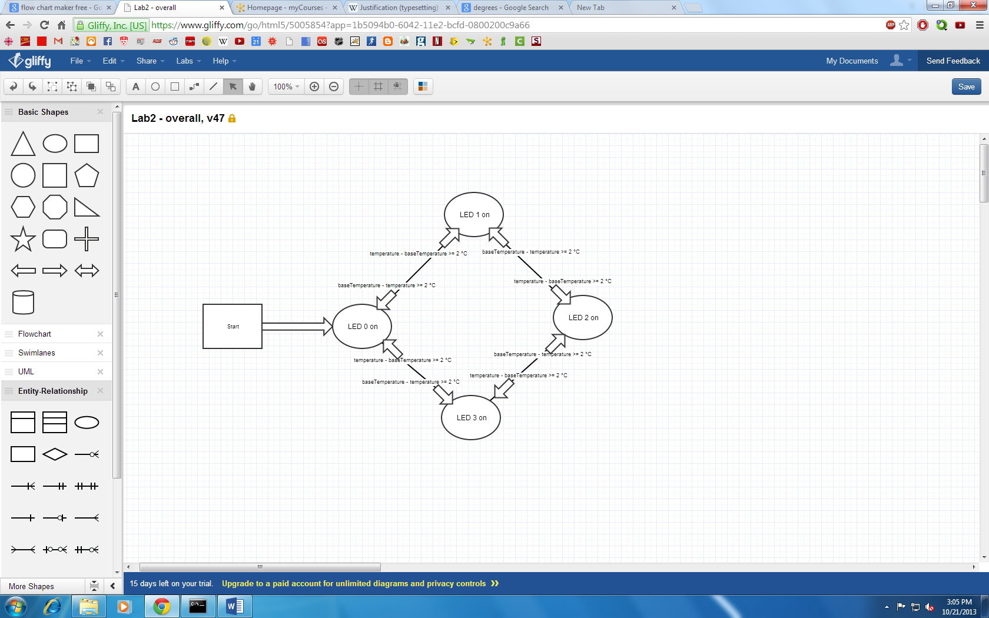

Figure : LED updating algorithm

The second mode implemented on the board is the PWM algorithm. As stated in Section 3, the PWM algorithm can be implemented using two counters. First, the SysTick timer must be set to a large frequency. In this case, 100MHz is used. The first counter will increment every 100MHz tick. The second counter will increment every time the first counter hits a certain value and wraps around. In this case the value used is 2000. Therefore, the first counter is essentially a timer of 50KHz (100MHz/2000).

The LEDs will be held on for a specific duration of that 50KHz cycle. The percentage of the cycle that the LEDs are held on for is computed as $\left(SecondCounterValue/2000\right)*100\%$. The duration of time will gradually increase (as the second counter increases). When the second counter reaches a value of 2000, the LEDs will be held on the entire duration of the 50KHz cycle, thus displaying at full brightness. The second counter resets at a value slightly larger than 2000 so that the LEDs are held at full brightness for a slightly extended period of time. After the second counter resets, the LEDs will be off for the first cycle.

In order to select between the two modes of operation, the system needed to be able to detect a button press. This required a simple debounce function to be implemented. Every time the main loop restarts, the function is called. The function first checks to see if the button’s GPIO pin is set. If the pin is not set, it means that the button is not pressed, and the function returns 0. If the bit is set, the function then waits 100 ms (using the SysTickTimer) and then checks the bit again. If the bit is not set, this means that the button has been fully pressed and then released, and the function returns 1. If the bit is still set, this means that the button has not been released yet, and the function waits again for 100 ms. The same check is then done again, and if the bit not set, it means that the button has been released, and the function returns 1. If the bit is still set, it means that the button has not been released, and it returns 0.

With a functioning button, it was possible to implement a mode selection. The main function uses an integer to keep track of which mode of operation the system is in. The function checks for a button press, and if it detects one, it will update the SystickTimer frequency, and then it will execute the correct routine (PWM if the system is in temperature tracking mode, and vice versa).

# 5. Testing and Observations

The first test required is to show that the temperature sensor was returning logical values. The voltage to temperature conversion equation was used to determine the actual temperatures of each corresponding voltage readings. To begin, the baseline temperature when the board is first plugged in (and cold) should be between 25 and 30 degrees Celsius. A baseline temperature around 28 degrees Celsius was observed in this implementation. To further test the reading and conversion, certain tools were used. A blow dryer was used to rapidly heat up the core. As expected, the actual Celsius temperature readings increase rapidly and the LEDs light up in a clockwise pattern. Then, the board can be left to cool. The temperature can be observed to slowly decrease with the LEDs lighting up in a counter clockwise fashion.

By allowing the board to operate in room temperature conditions for an extended period of time, a steady state temperature can be reached. In an ideal case, this temperature reading would be consistent and stable. However, since noise exists on the ADC, quite a bit of fluctuation can be observed on this reading. For this reason, a moving average filter was implemented on the temperature readings.

To test and optimize the moving average filter, a Matlab model was used to compare different buffer lengths. Four data sets were used, all data was temperature values output by the temperature sensor. For each data set, the raw data was plotted. A moving average filter was then applied to this data, with buffer lengths of 5, 10, 15 and 20. The filtered data was then plotted and compared with the raw data as seen in Figure 6. As expected, the moving average filter showed a significant reduction in the random fluctuations and noise. The various buffer lengths were then compared against each other. Figure 6 demonstrates four of these comparisons. It can be seen that a buffer length of 10 provides a significant improvement over 5, while a buffer length of 15 does not add a significant improvement over 10. Each subsequent increase in buffer length led to more accurate data representation. It was determined that a buffer length of 10 offered the best trade-off between noise reduction and memory usage.

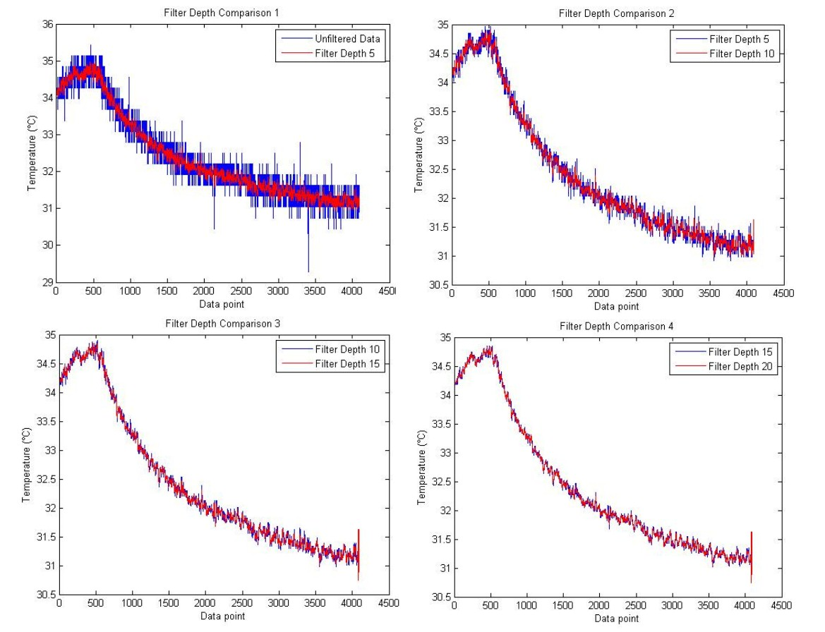

Figure : Matlab Filter Results

The rotating LEDs were tested by inspection. A “printf” function was added to the start of the function that updates the LEDs. The printout displayed the filtered temperature value each time the function was run, so that the temperature value was observable. Then, the board was turned on, and the temperature tracking enabled. The processor was warmed up by placing a finger on it, and the LEDs observed. After the processor had warmed up and the LEDs were observed rotating clockwise as expected, the processor was allowed to cool down and the LEDs were observed rotating counterclockwise, as expected.

As with testing the LEDs for temperature tracking, the PWM algorithm was tested by inspection. The length of the entire PWM cycle is known to be 4 seconds. In those 4 seconds, the LEDs must hit both maximum and minimum intensity. The minimum can be observed as the LED being completely off, while the maximum can be observed and compared to other fully on LEDs. As expected, when the PWM algorithm reaches 100% of the duty cycle, the LEDs have intensity comparable to a fully on LED. To further test the PWM algorithm, an oscilloscope can be connected to the pin of the LED. Tracing 4 seconds worth of data shows the LED being held on for a gradually increasing amount of time.

The push button debounce was tested simply by pressing the button, and observing if the LEDs changed from the rotating LEDs to the PWM. Various “types” of button presses were tested, such as pressing it quickly, holding the button down for a long period of time, and a normal press. It was found that with the double-check debounce routine, all of these pressed were detected correctly.

# 6. Conclusion

The STMFx board can effectively monitor its’ core temperature using an ADC. The data returned from the ADC is more or less accurate and therefore a moving average filter is required to ensure the accuracy of the conversion. The depth of the filter was expected to be a small value. In practice, a value of 10 was justifiably chosen. This depth allowed for improved accuracy without occupying a significant portion of system resources.

In this current implementation, the ADC was used in continuous conversion mode. However, it should be noted that this is an unnecessary use of system resources. Since the algorithm involves polling the sensor at 20Hz, a conversion could simply be run every 20Hz. Having the ADC in continuous conversion mode ensures that the reading returned is stable (not a transition value). For this reason, no flags are necessary to ensure that the ADC reading is finished (stable) before using it.

The PWM algorithm implemented ramps the LEDs from minimum to maximum intensity. It should be noted that this algorithm uses a linear ramp, however, the LEDs do not necessarily have a linear response. Therefore, the actual ramp of intensity observed is not linear.

The button press implemented functions exactly as desired. In the rare case that the press is not registered (usually because the press is too fast or not actually a press) the next subsequent press will have no problems. The debouncing algorithm successfully handles the bouncing of the button signal after a press.

# Appendix

# Appendix A - References

Express, E. (n.d.). *Contact Bounce and De-Bouncing*. Retrieved from http://www.elexp.com/t_bounc.htm

Instruments, I. S. (n.d.). Retrieved from http://www.imagesco.com/articles/nitinol/07.html

STMicroelectronics. (2013). STM32F405xx & STM32F407xx Datasheet DocID022152 Rev 4.